Week 3: Bootstrap / Homework Assignment

1. Name five different Bootstrap components and describe how they work.

Five different bootstraps components are “alerts”, “buttons”, “badge”, “dropdown”, and “navbar”.

1. **Alerts:** Works as a pop-up after a particular message and displays a particular message.
2. **Buttons:** It’s a customizable button that can be used to perform actions in forms and other dialogue boxes.
3. **Badge:** A badge used a labeling component that adds additional information.
4. **Dropdown:** Are used in menus in a lost format, using links. They’re considered contextual and toggleable overlays.
5. **Navbar:** A navigation bar is used in a header when they are located at the top of a webpage.

2. How does the Bootstrap grid system work?

A bootstrap grid is a system that is used when using bootstrap. Within a grid-system it utilizes a series of layouts (container, rows, column and align content). It allows up to 12 columns across a page, which you can change around depending on how you want to layout your page (i.e. grouping columns together or creating wider columns). It's very responsive and columns will rearrange depending on the size of your screen size. On small screens, it’s better to have the content stacked.

Below is an example of the 12 columns across a page:

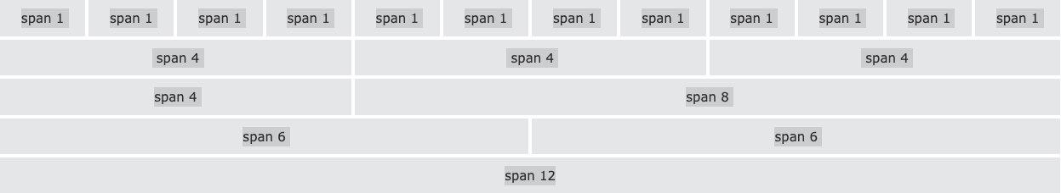

Source:

1. <https://www.geeksforgeeks.org/explain-the-components-of-bootstrap/>
2. <https://www.w3schools.com/bootstrap/bootstrap_grid_system.asp>

By: Sushana Thomas